Dart Score Tracker

Design document

G00347352 - aaron hannon

2019

# Introduction

The application I decided to do is a Dart score tracker with various dart game modes for example Standard 701,501,301, cricket and Around the clock. Depending on time constraints I will add more game modes. The app will allow you to pick your mode and it will bring you to the match setup page where here you will add your number of players and set the sets/legs. Then you will be brought to the actual Score tracker which will display each player’s score and a number dial at the bottom. So, when a player finishes their turn you input their score and it gets deducted from their total (If it is standard game mode) and it will display what positions on the board they must hit to win the leg in the next round (Must end on a double). The player wins if they are the first to get to 0 but must end on a double.

# Features

* Create new game
* Various game modes
* Up to 4 players
* Game stats locally stored

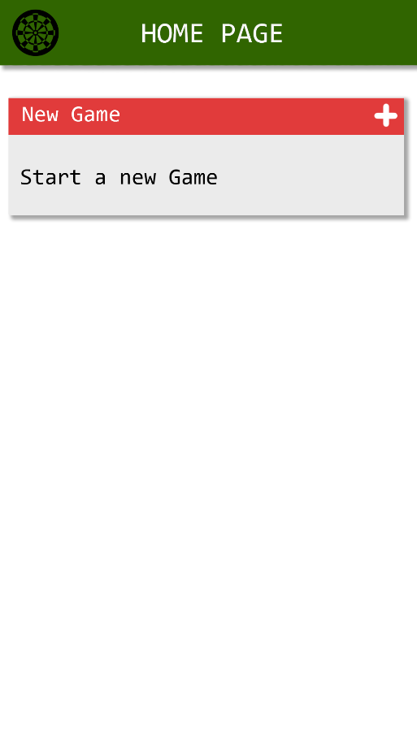

# UI

After looking at similar apps, here are some UI ideas I have come up with in Photoshop:

## Homepage:

The home page has two buttons, one is the dart board at the top left of the app, this button will allow you to view all of your stats. The second button is the plus that allows you to create a new game. Throughout the app I will be going with a green/red colour scheme as those are the common colours on most dart boards.

## 

(NEW GAME) (MATCH SETUP)

## New Game:

This is the new game page it allows you to select which game mode you would like keep track of the scores for.

## Match Setup:

This is a screenshot from a similar app I found whilst doing some research. The app is called DartCounter. For the Match setup page I would do something similar where you can add up to 4 players, change the starting score and set the sets/legs.

## Score Tracker Page:

This is the score tracking page. Here is where most of the calculations must be done. What ever the player scores will be deducted from the starting score that was set in the Match setup e.g 301,501,701. The red text shows what a player must hit to win and must always end on a Double or “D” as shown in the mock up image. There is an input box where you enter a players score after they have thrown 3 darts and a grid of buttons below that to select the score.

# Conclusion

In theory this is a simple application however, calculating what darts need to be thrown to win might be a bit challenging. Also, storing all the statistics for each game and displaying them might be quite difficult too. I plan to get the project done in 2-3 weeks depending on how many game modes I add. This is my design document for my Dart score tracker application.